Content

Content 1

Welcome to the -TITAN Adapter 2

Features 3

Charging 4

How to turn the -TITAN Adapter on/off 5

Connect -TITAN with a Bluetooth device 6

List of -TITAN Adapter functions, operations & status 7

Status of indicators 8

Specifications 9

Welcome to the -TITAN

Bluetooth Adapter

-TITAN adapter is compact, lightweight and easy to use. Utilizing Low Energy Bluetooth v5.0 chipset it enables faster connections and clearer transmissions. Complete -TITAN adapter by pairing it with the Blu-PTT.

Please read this manual carefully before using the -TITAN adapter.

-TITAN Features

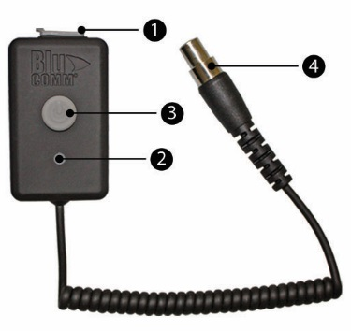

1. USB Charging Port

2. Status LED

3. Power/Pairing button

4. Headset Connector

Charging

1. Please fully charge the  -TITAN adapter before using it the first time.

2. When the -TITAN adapter is connected to the charger a solid red LED light indicates that the -TITAN adapter is charging, when the LED turns solid green the -TITAN is fully charged.

* Talk time: about 29 hours.
* Connected Standby Time: about 60 hours.
* Adapter off Standby Time: about 30 days

How to turn -TITAN on and off

Press the power button until the LED indicator lights white. The indicator will stay white until it finds the device it is paired with.

Note:

Whenever -TITAN is turned on it will automatically connect with the last Bluetooth device it was connected with.

To turn it off, press and hold the power button.

Connecting -TITAN Adapter with a Bluetooth device

1. Press once to turn on the Blu Adapter.   
 The LED will become solid white indicating no device is currently connected.

2. Put the Bluetooth device into pairing mode following its pairing/connecting instructions.

3. When the -TITAN LED is solid blue only, it is paired and connected.

-TITAN supports the “Headset” Bluetooth audio profile.

List of -TITAN functions, operations and status

|  |  |  |
| --- | --- | --- |
| Function | Button | Status indicator |
| Turn on | Press once | Solid White LED |
| Turn off | Press and Hold for 3 seconds | No LED indication |
| Pairing Mode | No button press needed | Solid Blue LED |
| Auto connect | When turned on | Blue light turns on after 4 seconds |
| Mode Change | Single press to change mode to YouTube and then back to PTT | Pink LED lights for You tube and Blue LED light for PTT |

LED Status indicators

Charging cable connected

|  |  |
| --- | --- |
| **Indicator** | **Function** |
| Red light | charging |
| Green light | Fully charged |

Charging cable disconnected

|  |  |
| --- | --- |
| **Indicator** | **Function** |
| Solid White LED turns on | Pairing Mode |
| Solid Blue LED turns on | Powered on |
| Solid white LED turns on | Lost connection |

Specifications

Type: -Headset Bluetooth adapter

Bluetooth specification: V 5.0 CLASS 3

Supported modes: HFP/A2DP/AVRCP/HSP/ GAVDP/IoP/SPP/BLE

Frequency range: 2.4 GHz

Operating range: within 35 feet

Charge time: 2 – 3 hours

Talk time: about 29 hours.

Standby time: about 60 hours

Note: The above stated standby and talk times vary depending on use.

All logos and brand names are the property of their respective trademark owners.The Bluetooth word mark and logos are owned by the Bluetooth SIGand used under license by Klein Electronics, Inc.